Assignment-4

|  |  |
| --- | --- |
| Assignment Date | 20 October 2022 |
| Student Name | MADALA TEJA |
| Student Roll Number | 210419106059 |
| Maximum Marks | 2 Marks |

Question-I:

Write code and connections in work for the ultrasonic sensor.

Whenever the distance is less than 100 cms send an "alert" to the IBM cloud and display in the device recent events.

Upload document with wokwi share link and images of IBM cloud

Solution :

#include <WiFi.h>

#include <PubSubC1ient.h> #include

WiFiC1ient wifiC1ient;

#define ORG "nhpwjc"

#define DEVICE_TYPE "raspberypi"

#define DEVICE ID "12345"

#define TOKEN "123456789" #define speed 0.034

char server[] = ORG " .messaging.internetofthings.ibmcloud.com" ; char publish Topic[] - " iot -2/evt/Data/fmt/j son " ; char topic[] = " iot-2/ cmd/home/fmt/String" ; char authMethod[] — "use-token-auth" ; char token[] = TOKEN; char clientld[] -- "d:" ORG DEVICE TYPE DEVICE ID; PubSubC1ient client(server, 1883, wifiC1ient); void publishData();

const int trigpin=5; const int echopin=18; String command; String data=

long duration; int dist;

void setup()

Serial begin(1152ØO); pinMode(trigpin, OUTPUT) pinMode (echopin, INPUT) wifiConnect(); mqttConnect();

void loop() {

publishData(); delay (500);

if ( !client.loop())

{ mqttConnect();

void wifiConnect() {

Serial. print("Connecting to 'I ); Serial. print( "Wifi " ) ; WiFi.begin( "Wokwi -GUEST" , while (WiFi.status() WL CONNECTED)  delay(500);

Serial. print

Serial. print("WiFi connected, IP address: Serial. print In(WiFi. locallP());

void mqttConnect() { if ( ! client. connected()) {

Serial. print("Reconnecting MQTT client to Serial . println(server) ; while ( ! client. connect(clientld, authMethod, token)) { Serial. print delay(1000);

initManagedDevice( ) ;

Serial. printlno;

void initManagedDevice() { if (client. subscribe(topic))

 Serial. println(client . subscribe (topic));

Serial. println("subscribe to cmd OK");

} else {

Serial. println("subscribe to cmd FAILED");

void publishData()

digitalWrite(trigpin, digitalWrite(trigpin,HIGH) delayMicroseconds(10 digitalWrite(tr1gp1n,• • LOW); duration=pulseln(echopin,HIGH) dist=duration*speed/2;

DynamicJsonDocumen t doc(1024); String payload; doc [ "AlertDistance : " ]=dist; payload); delay (3000); Serial. print ( " " ) ;

Serial. print("Sending payload: Serial. print In (payload) ; if (client. publish(pub1ishTopic, (char*) payload.c_str())) {

Serial. print1n("Pub1ish OK");

} else {

Serial. print In("Publish FAILED");

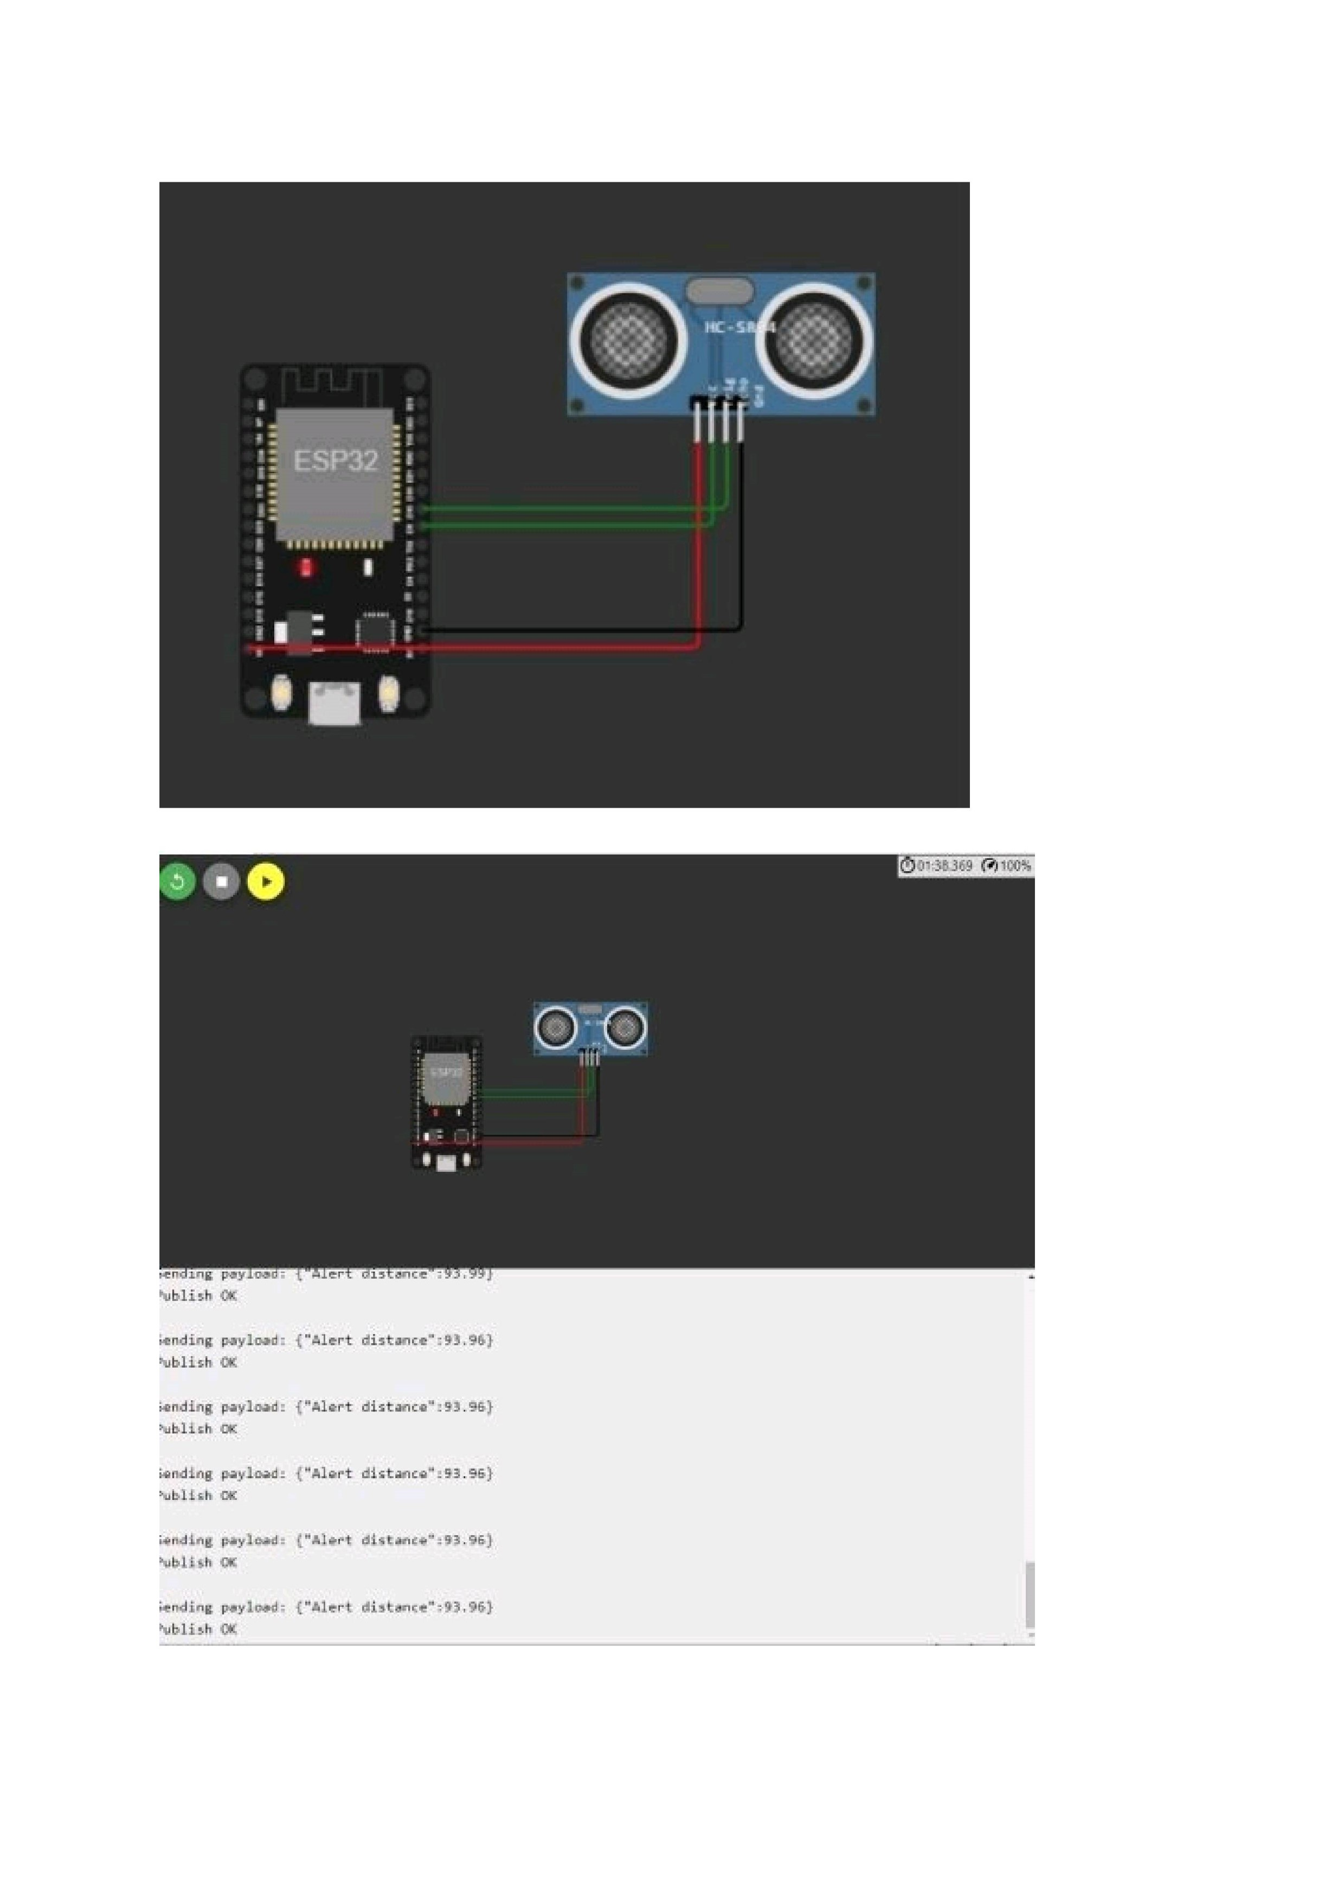

|  |  |
| --- | --- |
|  | 30 |
|  |
|
|